Lab4 – Cloudlab

# Summary

In this lab, we learn about using Cloud lab, setting up, and running experiments. The lab teaches us to remotely log in to a cloud server and interact with the nodes. In exercise 3, we experiment with using multiple TCP connections parallelly and assessing their performance. We go on further to assess if each of the ports on the servers(eth0, eth1, and lo) are accessible by the client, as well as systems on the world wide web/internet.

*Note: Throughout the lab, I ran different experiments since the old ones terminated, so the IP addresses are not fixed throughout my report.*

## Exercise 1

*List view*

## Exercise 2

*Client and Server Login page*

## Exercise 3

*Ifconfig*

*Server IP: 172.17.220.2*

*Client IP: 172.17.220.1*

man page of iperf

*-p 2*

*-p 4*

*-p 20*

This is what we get by changing the number of parallel connections.

We notice that for 2 parallel connections, the throughput is 95.8Mbps and the connection speed is between 7.81 Mbps and 87.1Mbps. Increasing the number of parallel connections initially improves throughput. This is seen when the number of parallel connections is made to 4. Here we see that the throughput is 96.7Mbps and the connection speed ranges from 11.5Mbps to 64Mbps. As we considerably increase the number of parallel connections, the returns diminish. As seen, when the number of parallel connections is 20, throughput decreases to 95.7Mbps, and individual connections range from 2.87Mbps to 8.08Mbps.

So we can infer that an initial increase in parallel connections improves performance, after which it plateaus and doesn’t increase further.

5)

**The 3 interfaces for the server machine**

***For eth0:***

1. *Interface with the client*

1. *Interface with the World wide Web*

***For the eth1:***

1. *Interface with the client*

1. *Interface with the World wide Web*

***For lo:***

1. *Interface with the client*

***The client is not able to ping the server on port ‘lo’.***

1. *Interface with the World wide Web*

*Since 127.0.0.1 is a generic local IP address, it will work on every computer. This does not mean that we are receiving the ping sent via the ‘lo’ port. This can be justified by running traceroute on the ‘World wide Web PC’, in this case, my personal computer.*

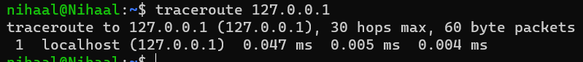

***Explanation for ‘Interface with World wide Web’***

*In the past, for cloudlab, eth0 was given a public IP address, but after the update, all ports only have a local IP. When we ping google.com, this works, but when we try to ping the cloudlab server from any PC on the internet, this fails. The reason as mentioned before, is since the server does not have a public IP address.*

## Exercise 4

